COMPUTER NETWORK LITE LAB ASSIGNMENT 2

VEDA MIRACLE PALAPARTHY

1.Is your browser running HTTP version 1.0 or 1.1? What version of HTTP is the server running?

Ans. 1.1 version

2.What languages (if any) does your browser indicate that it can accept to the server?

Ans. Accept-Language: en-US,en;q=0.9\r\n

3.What is the IP address of your computer? Of the gaia.cs.umass.edu server?

Ans. Internet Protocol Version 4, Src: 10.59.199.63, Dst: 128.119.245.12

4What is the status code returned from the server to your browser?

Ans. Last-Modified: Tue, 22 Aug 2023 18:02:30 GMT\r\n

5.When was the HTML file that you are retrieving last modified at the server?

Ans. Date: Mon, 11 Sep 2023 04:11:17 GMT\r\n

Last-Modified: Tue, 22 Aug 2023 18:02:30 GMT\r\n

6. How many bytes of content are being returned to your browser?

Ans. 111 bytes

7.By inspecting the raw data in the packet content window, do you see any headers within the data that are not displayed in the packet-listing window? If so, name one

ans. OCSP

8. Inspect the contents of the first HTTP GET request from your browser to the server. Do you see an “IF-MODIFIED-SINCE” line in the HTTP GET?

Ans.no

9.Inspect the contents of the server response. Did the server explicitly return the contents of the file? How can you tell?

Ans no because I don’t see line by line contents of the file.

10. Now inspect the contents of the second HTTP GET request from your browser to the server. Do you see an “IF-MODIFIED-SINCE:” line in the HTTP GET? If so, what information follows the “IF-MODIFIED-SINCE:” header?

Ans. yes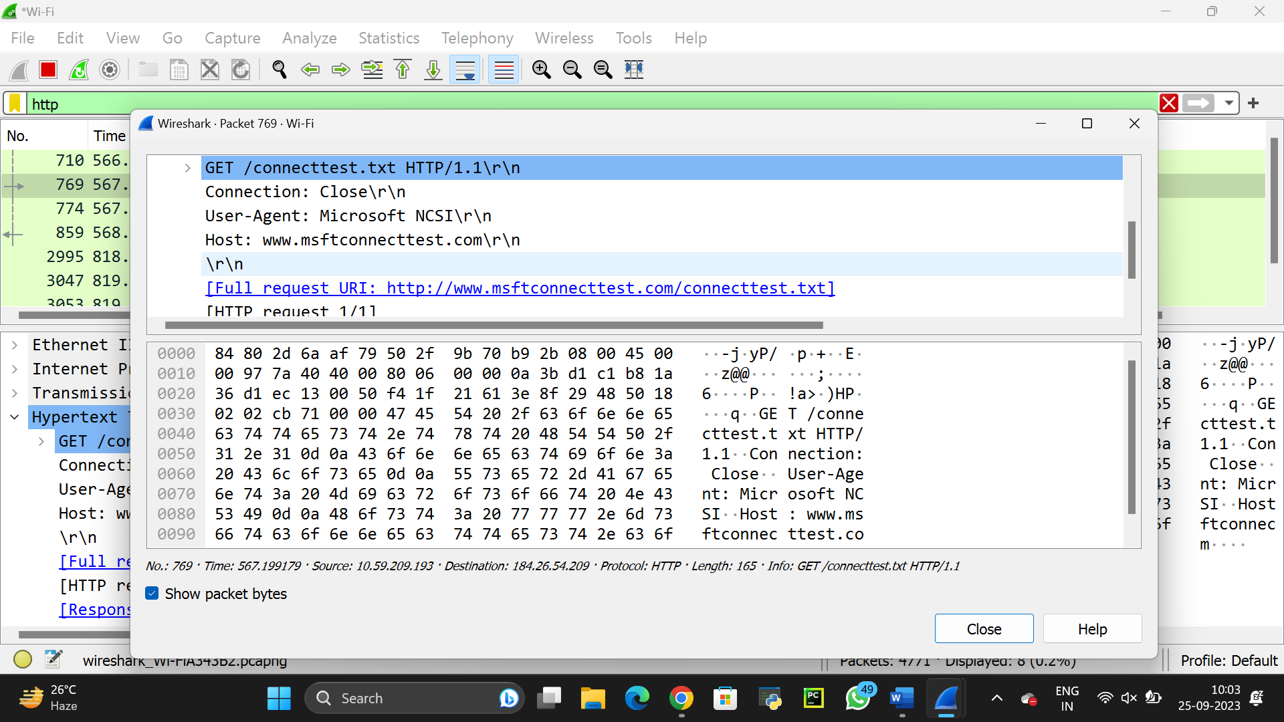

11. What is the HTTP status code and phrase returned from the server in response to this second HTTP GET? Did the server explicitly return the contents of the file?

explain

Ans. 769 567.199179 10.59.209.193 184.26.54.209 HTTP 165 GET /connecttest.txt HTTP/1.1

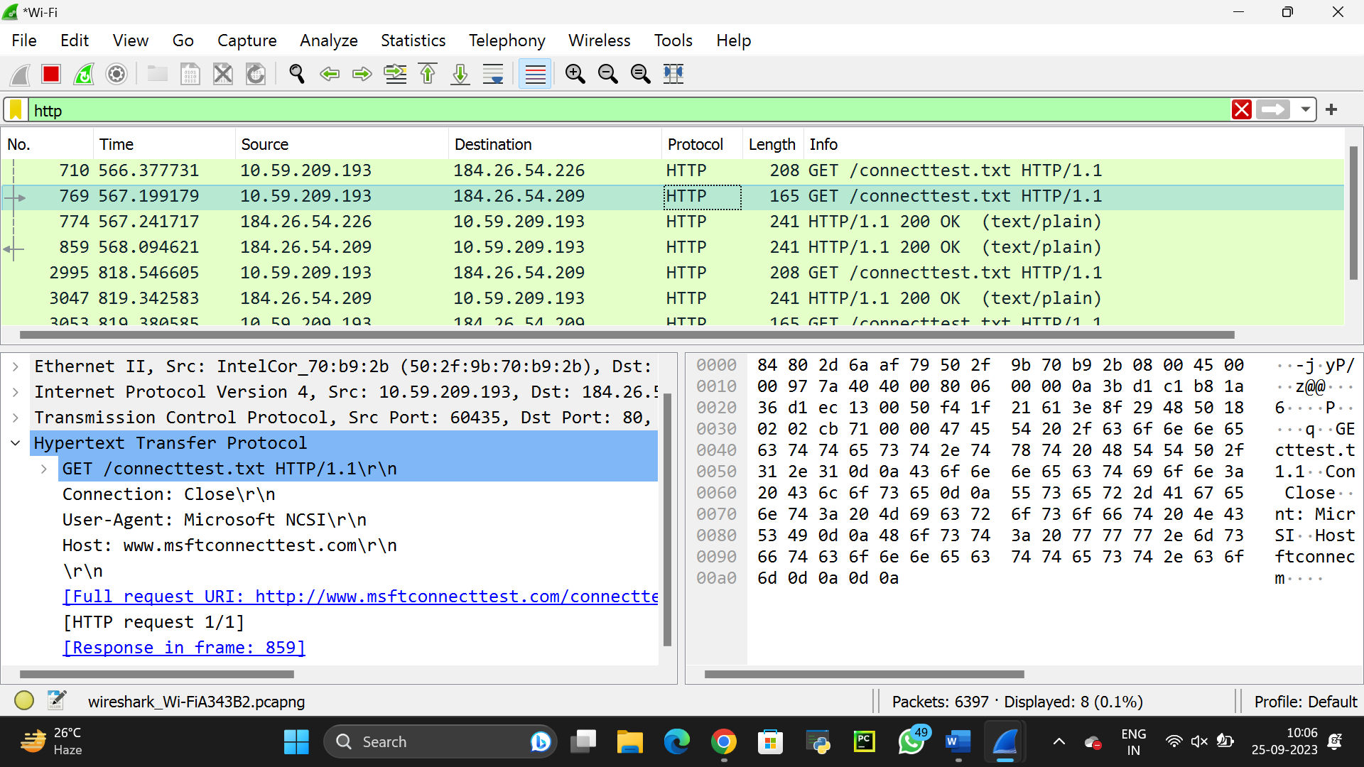

12. How many HTTP GET request messages did your browser send? Which packet number in the trace contains the GET message for the Bill or Rights? Ans 1.Sera

13. Which packet number in the trace contains the status code and phrase associated with the response to the HTTP GET request?

14. What is the status code and phrase in the response?

15. How many data-containing TCP segments were needed to carry the single HTTP response and the text of the Bill of Rights?

16.How many HTTP GET request messages did your browser send? To which Internet addresses were these GET requests sent?

1. Can you tell whether your browser downloaded the two images serially, or whether they were downloaded from the two web sites in parallel? Explain.